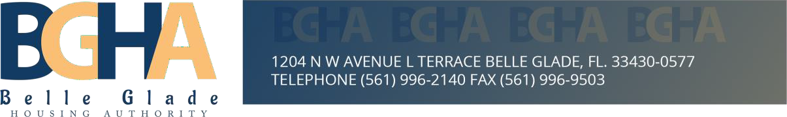

# Advertisement for Bid Proposals

# Okeechobee/Osceola Farm Labor Housing Renovation Project RFP# 011425

Owner: Belle Glade Housing Authority (BGHA)

Address: 1204 NW Avenue L Terrace Belle Glade, FL 33430

Property Name: Okeechobee/Osceola Farm Labor Housing Project

Property Location:

Site 1: Okeechobee Center

101 Everglades St. Belle Glade, FL. 33430

Site 2: Osceola Center

1204 NW Ave. L Belle Glade, FL. 33430.

Nelson and Associates, Inc, (Nelson), acting on behalf of BGHA is soliciting bid proposals from appropriately qualified contractors to furnish labor, materials, equipment, and services required to perform capital improvements for multi-family residential buildings identified here in, which are comprised of 712 units in the city of Belle Glade, Florida. The Scope of Work (SOW) outlines the details of work for the capital improvements at the Osceola and Okeechobee residential properties. These improvements include site development, building upgrades, and essential infrastructure improvements to enhance the living conditions of the residents and improve overall safety, ADA accessibility and functionality.

**Time and Date: All Bid Proposals must be received electronically and a hard copy together with the bid security at the BGHA office no later than 3:00 PM EST Friday March 14th, 2025.**

All material and equipment furnished, and work performed shall be in strict accordance with the plans and specifications, and contract documents pertaining thereto. Copies of said plans, specifications and all necessary documents, with related exhibits and attachments detailing the Scope of Work may be accessed and downloaded from the following website:

[Selective Renovation of: Okeechobee/Osceola Farm Labor Housing - DemandStar](https://www.demandstar.com/app/limited/bids/487150/details)

Copies of the Contract Documents may be examined at the BGHA Office at the address listed above during normal business hours 9:00 AM to 5:00 PM Monday through Friday.

In addition, copies of the full set of Contract Documents may be obtained at the office of Cool & Cobb Engineering Company at 203 W. Main Street, Avon Park FL 33825 upon payment of $1,500 for each set provided. Specific arrangements can be made by e-mail to:

[Mason@coolandcobb.com](mailto:Mason@coolandcobb.com) (and)

[Thomas@coolandcobb.com](mailto:Thomas@coolandcobb.com)

**Advertisement for Proposals – Page 2**

This project is financially assisted by the USDA Rural Development Administration (USDA-RD), and Palm Beach County (PBC). And as such, respondents must comply with all applicable Federal, State, and local laws and ordinances. The Owner reserves the right to waive or reject any and all proposals or waive any or all irregularities.

All contracts exceeding $10,000 shall contain a provision requiring compliance with Executive Order 11246, entitled, "Equal Employment Opportunity," as amended by Executive Order 11375 and as supplemented in Department of Labor regulations (41 CFR Part 60).

# SPECIAL NOTES:

* Time is of the essence. The selected General Contractor must demonstrate substantial experience with proven ability to adhere to a very strict and aggressive development timeline.
* A Bid Security must accompany each Bid Proposal in the amount equal to 5% of the Proposed Contract Amount. **And the contract documents impose additional compliance requirements on the contractor, and the attention of the bidder is directed to the contract documents and project manual.**
* Davis-Bacon prevailing wage rates shall apply to this project as well as bonding requirements of a separate Performance Bond and Payment Bond, each in the amount of 100% of the bid.
* There will be a **Mandatory Pre-bid Conference Meeting** on Tuesday, January 28th, 2025, at 10:00 AM, in the meeting room at the Belle Glade Housing Authority office at 1204 NW Avenue “L” Terrace Belle Glade, FL 33430 to discuss this solicitation and to help get prospective bidders acclimated to the properties, the scope of work and to answer questions prior to submission of proposals. Specific instructions for virtual attendance to the meeting will be posted on the following websites:

[network.demandstar.com](https://network.demandstar.com)

[nelsonasc.com](http://www.nelsonasc.com)

[bellegladeha.com](http://www.bellegladeha.com)

* During the Pre-bid Meeting, attendees will be informed of arrangements to be made to inspect units.
* All interested respondents are responsible for checking the websites for any comments or addenda or further announcements related to this solicitation. Further inquiries or questions may be directed to the individual listed below during normal business hours between 9:00 to 5:00 PM Monday through Friday.

Felipe Barsky, Project Manager

Email: [Felipe.Barsky@nelsonasc.com](mailto:Felipe.Barsky@nelsonasc.com.)

Cell: (561) 873-1907